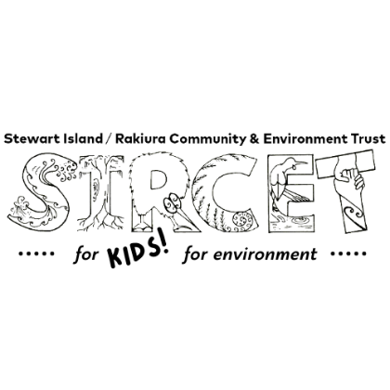
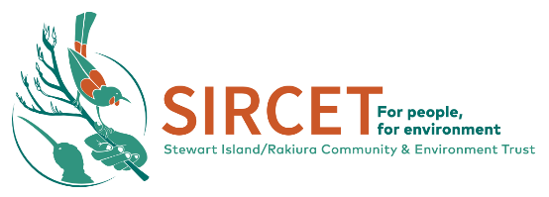

Thank you for your interest in bringing your group to visit SIRCET! This document is intended to give you more information about SIRCET and our work.

SIRCET’s main focus is environmental restoration. We do this by controlling both introduced mammal and plant pests in our project areas We aim to help improve the habitat for our native plant, invertebrate, bird, bat, and reptile species. We manage a Community Nursery, where native plants are grown for restoration planting and for resident gardens, and a Trap Library to support residents own trapping efforts. We host Kiwi Avoidance Training workshops to help resident and visiting dogs avoid kiwi. We monitor native species such as Kororā/little penguin. We coordinate volunteer input into a variety of conservation tasks and work closely with the local Halfmoon Bay School to support their Enviroschool initiatives. For more information see https://www.sircet.org.nz/

We are committed to conservation education, and are excited to share our story and ideas with your group.
We have some flexibility in what we can coordinate for your group. Some suggested activities are:

- A conservation talk as we clear rat trapping lines along Acker’s Point (if your group has access to transport, or can walk to the start of the track) or within the township (starting at Traill Park). A meeting point would be arranged where we would hold a safety talk before taking the group on a walk, showcasing native species along the way, clearing traps, and talking about conservation.
- Trap box / nest box making session (this is dependent on materials being available), which can be added onto the above trapping walk.
- Weeding or planting in our restoration areas. Depending on group size, the groups own tools may be required.
- Propagating plants or maintenance at the Community native nursery.

Sessions run for approximately two hours. We can tailor the experience to all age groups and fitness levels. We provide a health and safety induction and any training for the session. We do not provide transport, food, or drinks. We expect one adult supervisor per ten children. It can be helpful for your group to bring gloves for each student if you will be helping with nursery, planting, or a few pairs to share around if clearing rat traps.

Stewart Island is a wonderful place to visit, as the township is nestled in the forest and boasts a great diversity of native birds. As a volunteer, you will have the chance to see and hear many of these birds and have the satisfaction of knowing that you are contributing to their survival. For more information see: http://www.stewartisland.co.nz/

Please note that the weather on Stewart Island is very changeable at any time of year and can become quite wet, cold, and slippery at times. It is important that you bring suitable warm clothing, as well as good sturdy footwear. We encourage you to bring wet weather gear, along with food and drink for the activity. If the forecast is unfavourable there is the option to arrange an alternate conservation-based activity at your school camp base, or at the Community Centre or RSA/ Pavilion.

We are ever mindful of protecting our treasured biodiversity and ask that your group clear footwear of soil and seeds and check clothes and other belongings for seeds and pests (including invertebrates) before arriving to the island. Accidental stowaways are bad news for our native plants and animals.

We would appreciate a $75 (or more if you wish) donation, towards our habitat protection work from each group, per activity so that we can continue to provide you this conservation experience. Our account number is 12-3154-0103153-00 if you wish to use internet banking.

Please don't hesitate to contact me if you have any questions. We look forward to hearing from you!

Kā mihi

Emma Simpson-Boyce
Community Liaison
020 4167 4160
community@sircet.org.nz

